**My mat based yoga classes** are suitable for all ages, all abilities and all bodies. Student numbers are kept small to allow individual attention and there is a friendly, supportive, non-competitive feel to the class.

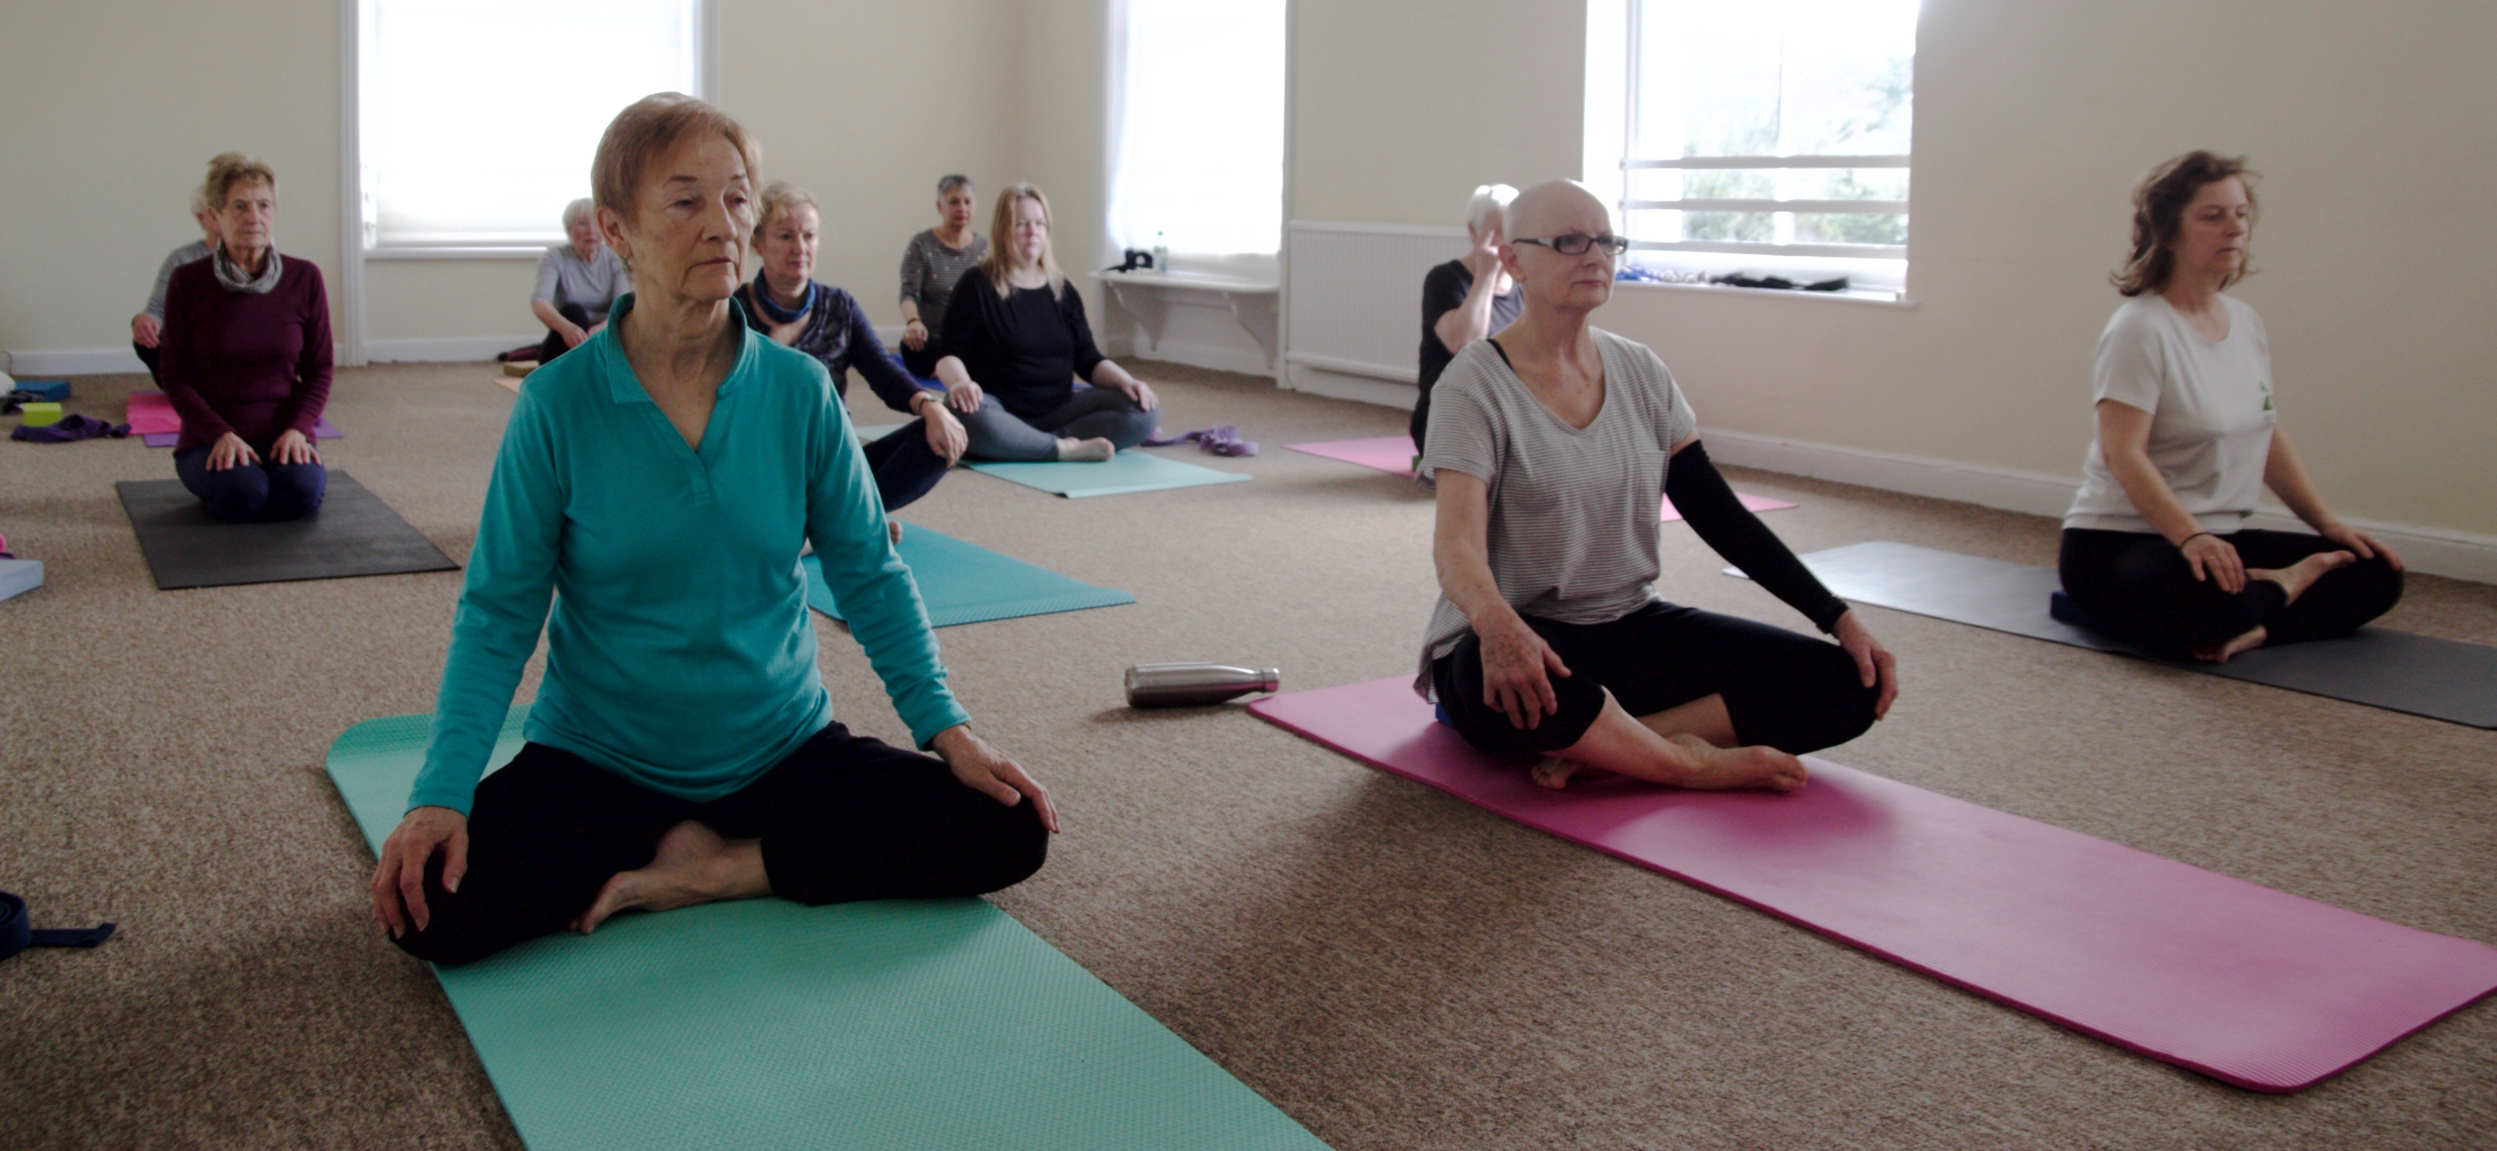

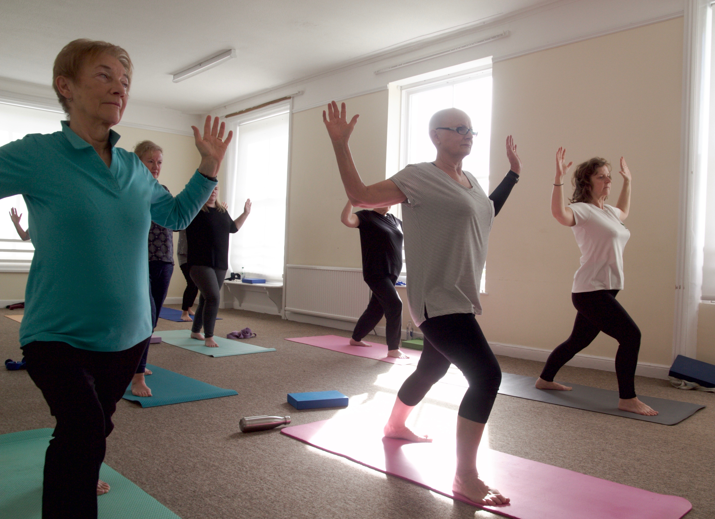

The classes begin with movements that mobilise and warm up the body, then gentle hatha yoga postures with some simple flowing sequences and breathing practices, finishing with a relaxation /meditation. Some of the many benefits include better mobility, strength, balance and body awareness, along with improved relaxation and concentration.

My style of yoga is grounded in yogic philosophy, and influenced by somatics and functional yoga. These approaches recognise that we are all uniquely different and postures and movements are modified to suit each individual. The focus of the practice is on the internal experience of yoga rather than whether we can get ourselves into a particular shape.

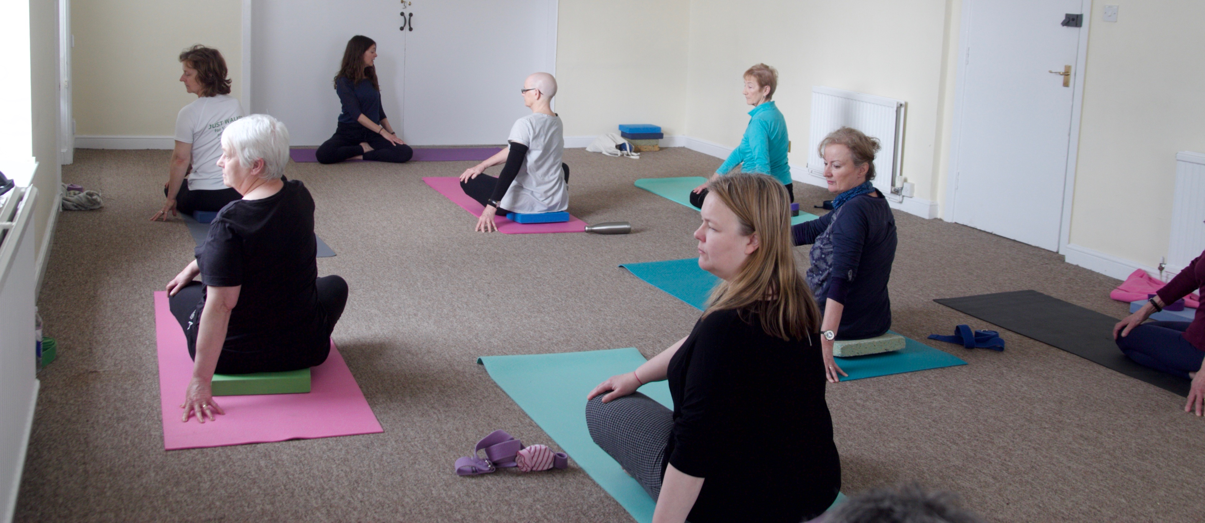

As well as weekly classes in term time I also offer workshops for mixed abilities and specific groups. In the past these have included mornings on the chakras, strength, freedom, balance and yoga nidra. When workshop dates are available they can be found under the News & Gallery tab.