**Chair Yoga classes**

Chair yoga classes are suitable for any students who cannot or do not want to practice on the floor.

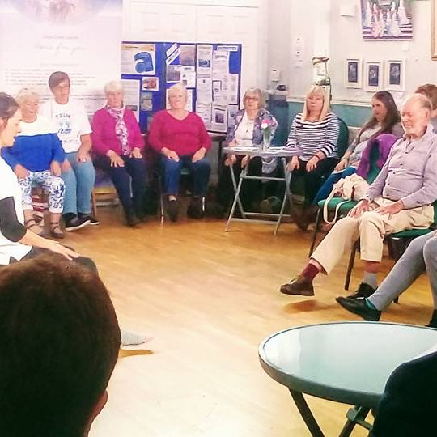The classes are small and welcoming and consist of gentle movements to mobilise and warm up the body from top to toe. There is work on releasing tension and aiding balance. Also a strong emphasis on relaxation and breathing techniques which may help to manage stress, anxiety and pain

Even though the movements are gentle they can be modified to suit all bodies so that everyone can work in a way that is safe and accessible.

I am a qualified gentle years yoga teacher ® and have trained to be able to specifically adapt yoga for adults with conditions such as hip/knee replacement, arthritis, MS or hypertension.