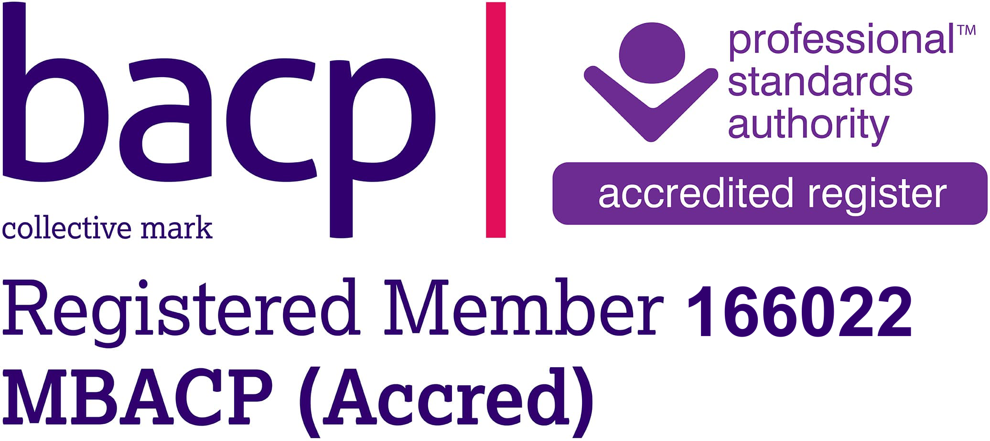

Mobile: 07743 401350
sally.cloke@gmail.com
www.sally.cloke.com

Sally Cloke Relationship Counselling

Terms and Conditions

By booking a consultation with Sally Cloke Couples Counselling, you agree to be bound by the following terms and conditions:

Booking

Couples counselling sessions of one hour or ninety minutes may be booked for online or in-person sessions.

Payment and fees

Payment is kindly requested in advance or at least before the appointment, either
by bank transfer or cash payment on the day.
Couple partners are deemed to be jointly responsible for the payment of the session fees. If either partner does not pay for the session, then the other partner will be held liable for the whole session fee.
Couples’ session: (One hour) £80.00
Individual session: (One hour) £68.00
Bank Details: Sally Cloke: Account number 10010863 Sort Code 11-14-91

Consultations
These can either be in person or will be conducted online by default using the Zoom platform (https://zoom.us/). Alternative online connection services may be used from time to time by prior mutual agreement. Ordinarily, prior to the appointment, for an online consultation Sally Cloke Counselling will provide a meeting invitation via email that will include a link for joining the session. All session appointments will be scheduled with reference to London UK time and will be conducted in English.
Cancellation Policy
Clients are required to provide a minimum of 24 hours' notice in the event that they are unable to attend a session they have booked. Otherwise, they remain (jointly and severally in the case of couple partners) liable for full payment of the session fee.
In the event that one partner provides less than 24-hours notice of non-attendance of a scheduled couple session, while the other partner attends, the full couple session fee remains payable. Where a partner provides more than 24-hours notice of non-attendance of a scheduled couple session and the other partner attends, it will be charged as an individual session.
Where clients request the rescheduling of a booked session with less than 24-hours notice, this will be treated as a cancellation.
Sally Cloke Counselling will endeavour to provide clients with at least 24-hours notice in the event that a counsellor has to reschedule a session due to unforeseen circumstances.
In the event that Sally Cloke Counselling is unable to deliver a service that has been booked and fully paid for in advance, our liability will be limited to a full refund of the payment received.

Conduct of Sessions
Sessions begin and end at the appointment times agreed in advance. It is the client’s responsibility to arrive on time and will normally not run over in the event of a late arrival. Should only one partner be available on time for a couple appointment, they have the option to begin the session if they wish. If Sally Cloke Counselling should be unable to begin a session on time or needs to terminate a session before the pre-arranged time, we will endeavour to make up any loss of time by mutual agreement with the client.
i) I aim to provide a safe environment in which to explore relationships. I therefore kindly request that clients:
ii) Conduct themselves with due respect to all parties attending sessions and avoid blaming, threatening, or otherwise abusive language or behaviour.
iii) Please refrain from using phones, tablets, or similar devices during sessions unless to facilitate an online session.
Commit to the counselling process and its aims (as mutually agreed by all parties concerned) throughout the period during which sessions are undertaken, both during and outside session times.

Confidentiality (please also refer to our Data Protection Privacy Notice below)

Counselling involves the discussion of sensitive, personal information. This information, in conjunction with the identity of the client, will not be disclosed to external parties other than in the following exceptional circumstances, reserves the right, or may be bound by law, to break confidentiality.

i)Where Sally Cloke Counselling has reason to believe that there is a serious risk of harm to a client or others with whom a client may come into contact. Under these circumstances, Sally Cloke Counselling may need to consult a supervisor and/or contact the client’s GP or other health professional or, in emergency situations, call the police. Sally Cloke Counselling will always endeavour to discuss this with the client beforehand, but under certain circumstances (e.g., where life is at risk), this may not be possible;

ii) Where a client informs Sally Cloke Counselling that they were/are involved in or have information about acts of terrorism, either being planned or which have already taken place, Sally Cloke Counselling is legally obliged to inform the police, without giving notice to the client (Terrorism Act 2000, section 38B);

iii) Where the courts or the police order or require the disclosure of information (e.g., where a client has information about the whereabouts of a missing child who is in care – section 50 Children Act 1989), Sally Cloke Couples Counselling would need to consider whether breaking confidentiality is required.

iv) Where Sally Cloke Couples Counselling receives a specific written request from the one of the clients to share information with a named third party (e.g., a legal representative).
Please be aware that the use of third-party online services necessarily has implications for security and confidentiality. Sally Cloke Counselling accepts no liability whatsoever for any such breaches that may occur in the course of, or as a result of using our services.
In accordance with recognised working practices, Sally Cloke Counselling may consult a third-party counselling professional for supervision of their work. In such instances, while actual scenarios presented by clients may be shared, the identity of clients will not be disclosed.

Seeing Couple Partners Individually, Private Communication & Issues of Confidentiality
Sometimes, it may be helpful for partners to attend some individual sessions with their couple counsellor. Under these circumstances, there needs to be a prior agreement regarding what happens if either individual reveals information to the counsellor that they do not want their partner to know. This same agreement will also apply to any private communication that might take place between either partner and the counsellor outside session times, or when only one partner is present for a couple session.
The default policy of Sally Cloke Counselling regarding private information is as follows:
i)If such information is revealed in an individual session or via other private communication, the counsellor will endeavour to maintain confidentiality;
ii) The counsellor can only break confidentiality under certain ethical circumstances (outlined above under ‘Confidentiality’);
iii) While confidentiality will be respected, where the counsellor believes that disclosure of the information is in the best interests of the relationship, the therapist will strongly encourage the client to reveal the private information to their partner;
iv) The matter of whether or not a partner has requested or attended an individual session (or otherwise communicated private information to the counsellor) is not subject to confidentiality.
As an alternative to the default confidentiality policy (above), partners can instead individually choose a policy of transparency with regard to their disclosures during individual sessions, or at other times outside couple sessions. A policy of transparency means that the counsellor will not hold secrets and is free to make reference to or share any disclosures with the other partner. Furthermore:
i)Each partner has the option to individually elect to switch to a policy of transparency, and so partners may choose differing policies;
ii) Switching to transparency from the default policy of confidentiality will be by prior agreement between the partner and counsellor;
iii) An individual will be made aware if their partner opts for a policy of transparency.

General Information on Confidentiality vs. Transparency
There are a number of pros and cons with either way of working, as set out below: Confidentiality-Policy.
Pros:
• Historically, client confidentiality has been one of the greatest ethical obligations owed by the counsellor; both to protect clients and to allow clients to speak freely and safely without fear of social condemnation or retribution. The duty to maintain confidentiality is set down within the code of ethics by virtually all professional therapy organisations. Without such a policy, either partner may feel unable to begin to raise fundamental issues, which, with the agreement of the client and support from the counsellor, might ultimately be successfully addressed in a subsequent couple session;
• A client may be more relaxed and forthcoming when seen individually, on the basis that what they say will be treated as confidential by the counsellor;
• The counsellor is arguably able to do better work knowing all the facts;
• The ethical principle of 'self-determination', or ‘autonomy’ requires that clients can make up their own minds whether or not they wish to reveal private information to their partner. If they reveal such information to the counsellor, it is not up to the counsellor to force a decision on the client to disclose. This could be seen as an imposition of the counsellor’s personal values on the couple;
• There are potentially some secrets or private information pertaining to a client's past (such as abuse as a child, a twenty-year-old affair, or occasional illicit drug use well before meeting their partner), which may be better left undisclosed since disclosure could be unhelpful or even detrimental to the relationship;
Cons:
• With the assurance of complete confidentiality, a client may reveal something they wish to keep from their partner (such as an affair). In this event, the counsellor must hold the secret or private information, which could be to the benefit of one partner and the detriment of the other. The result might be a therapeutic imbalance created by the secret or private information being kept between the counsellor and one partner, which is potentially counter-productive to couple therapy and compromises the working alliance. Should the unaware partner learn of this collaboration between the counsellor and the other partner, he or she is likely to lose trust in the counsellor and may terminate therapy;
• Upon hearing a secret or private information, the counsellor may begin to lose empathy for, or feel resentment towards the secret-holder;
• The counsellor may feel guilty for deceiving the unaware partner and consciously or unconsciously collude with that partner to make amends;
• The counsellor may not be cognitively able to hold the secret or private information, and it may be accidentally revealed.
Transparency ('no secrets') Policy
Pros:
• The counsellor does not risk alienating either partner by holding ‘secrets’ or private information (see 'confidentiality' above for the risks and difficulties of holding secrets or private information);
• The counsellor is likely to feel more comfortable with both clients, as the counsellor will not be holding secrets or private information;
• The counsellor is more likely to be trusted by both partners, because the counsellor will never be hiding anything;
• The counsellor is more likely to build a strong working alliance with both partners;
Cons:
• Either partner may be unwilling to share certain details (such as an affair), which may render counselling less effective than it could be;
• If under a prior general agreement for transparency, a partner subsequently reveals something they want the counsellor to keep secret (e.g., during an individual session), the choices for the counsellor are to honour the original agreement and break confidentiality, compromise the original agreement by keeping the secret, or end couple sessions. Sometimes, the counsellor might suggest an intermediate solution; that there should be a certain maximum number of individual sessions to work on supporting the client to disclose a secret or private information to their partner in a couple session.

Data Protection Privacy Notice
What personal data do I hold?
Sally Cloke Counselling holds client personal data, which may include: name, email address, telephone number, age, partner's name (where appropriate), relationship status, number of children, details pertaining to relationship issues, mental health status, addictions, use of recreational drugs, domestic abuse, self-harming and suicide risk.
Where does personal data come from?
Prospective and current clients supply personal data when contacting Sally Cloke Counselling by email, completing a form on my website, or completing a questionnaire.
With whom do I share personal data?
Sally Cloke Counselling endeavours to ensure that personal data is stored securely and confidentially, and is used in a safe and ethical manner, in line with EU General Data Protection Regulations, May 2018. Sally Cloke Counselling does not share personal data with other parties without client consent, excepting the circumstances detailed in our Confidentiality policy (outlined above). The security of personal data sent to us via third-party systems, such as email, necessarily lies outside our control, and so clients should be aware of any attendant risks to their personal data of using such systems. For the purposes of the General Data Protection Regulations (GDPR) 2018, the 'Data Controller' is Sally Cloke
What do I use personal data for?
Sally Cloke Counselling uses your personal data for the following:
To respond to prospective clients with information when they have expressed an interest in my services, including arranging appointment;
To request further information from prospective clients, or suggest further action;
To understand how best to support clients through counselling. For example, the information a client might provide through completing a questionnaire helps me to determine how to proceed in working with them, and this may include carrying out a risk-assessment. This practise is in accordance with professional guidelines and necessarily requires the client to disclose sensitive personal information.
Consent, data retention and disposal
By freely submitting personal data, a client is deemed to have consented to Sally Cloke Counselling using personal data under the terms outlined in this Privacy Notice.
Personal data is retained by us for a maximum period of seven years, as required for the exercise or defence of legal claims, after which it is deleted or otherwise disposed of as confidential waste.
Your rights
In accordance with the General Data Protection Regulation 2018, clients have the following rights: To be informed about our collection and use of your personal data;
To make a verbal or written request to access your personal data held by us, and for us to supply this free of charge within 1-month;
To have inaccurate personal data held by us rectified, or completed if incomplete;
To request verbally or in writing that we erase your personal data held by us;
To request verbally or in writing to have your personal data held by us restricted or suppressed;
To transfer any personal data previously provided to us to another party;
To object to our processing of personal data held by us, and to stop its use for specific purposes, such as direct marketing;
Not to have your personal data subject to automated decision-making processes, other than those allowed under GDPR Article 22.
Compliance Issues
Please contact Sally Cloke Counselling should you have any questions or concerns about the ways in which we collect or use personal data.
Sally Cloke Counselling reserve the right to amend terms & conditions from time to time without prior notice.

